

MISSION 0 MARKETING ASSOCIATION PROJECT

2

# CONTENTS:

* Introduction and Objectives
* Design Highlights
* Website Walkthrough
* Technical Features

## I am excited to present to you the new and improved website design for Marketing Association NZ.

The goal with this design was to create a user-friendly, modern, and visually appealing website.

file:///C:/Users/jeann/OneDrive/Documents/!2024/Mission_R eady/Mission_1/Mission_1.1.html#

Repo Link: <https://github.com/jeanz888/mission0>

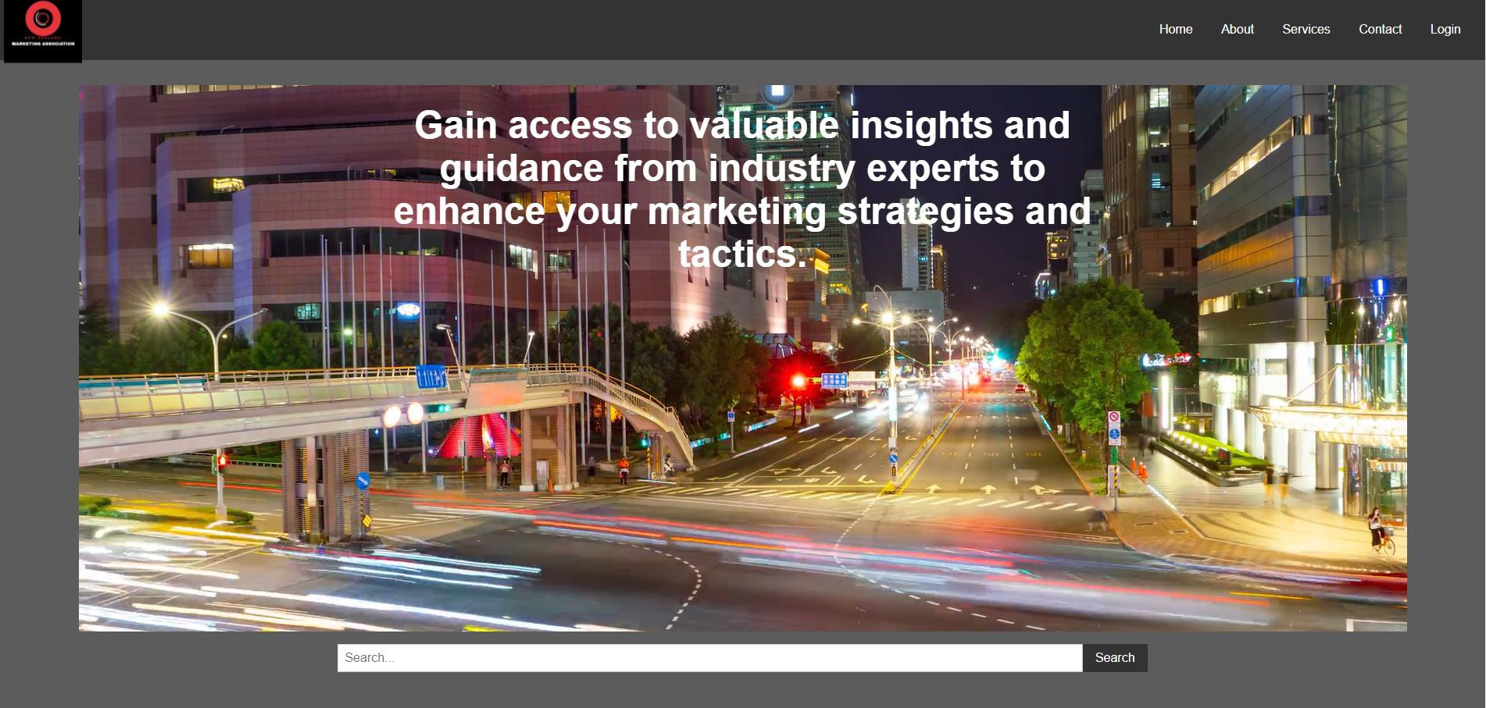

4

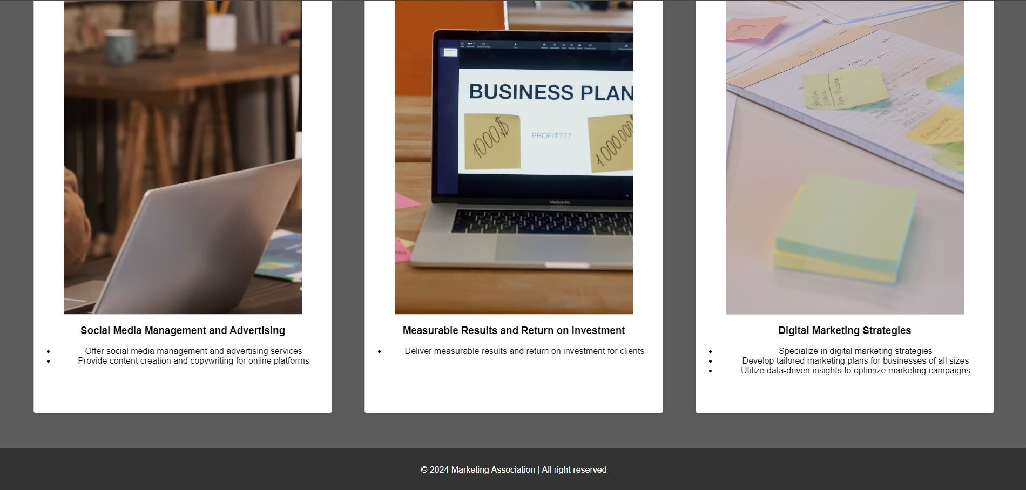

5

# OBJECTIVES

I aimed to achieve a modern look while ensuring that the website is fully responsive, adapting smoothly to various screen sizes, from desktops to mobile devices.

7



# DESIGN HIGHLIGHTS

**Responsive Design:** The website automatically adjusts its layout to provide an optimal viewing experience on any device.

**Clean and Modern Layout:** The design is minimalist yet engaging, with a focus on readability and user engagement.

**Enhanced User Experience:** I have streamlined the navigation to make it intuitive, ensuring visitors can easily find the information they need.

8

# WEBSITE WALK THROUGH

Let’s take a detailed look at the different sections

of the website:

9



**HEADER AND NAVIGATION**

**Header and Navigation**

The header features the company logo and a navigation bar with links to essential sections such as:

Home, About, Services, Contact, and Login.

The design is clean and ensures easy access to key areas of the site.

10

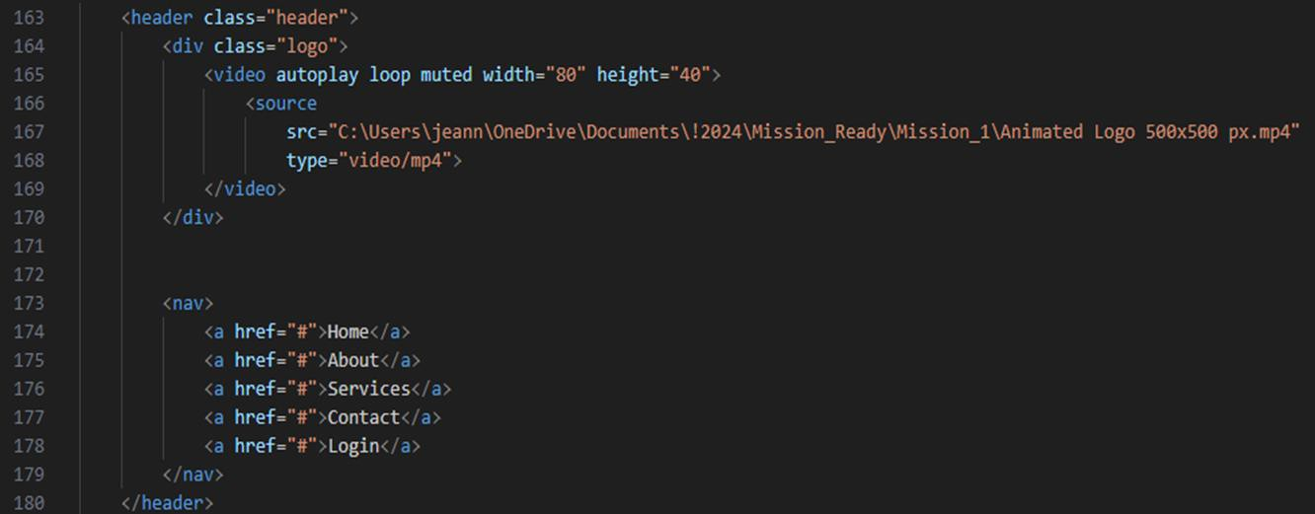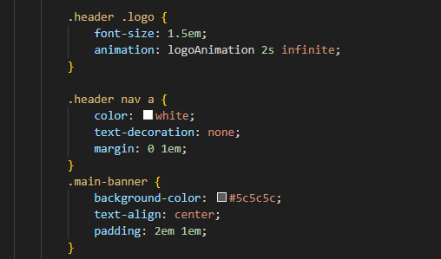

11

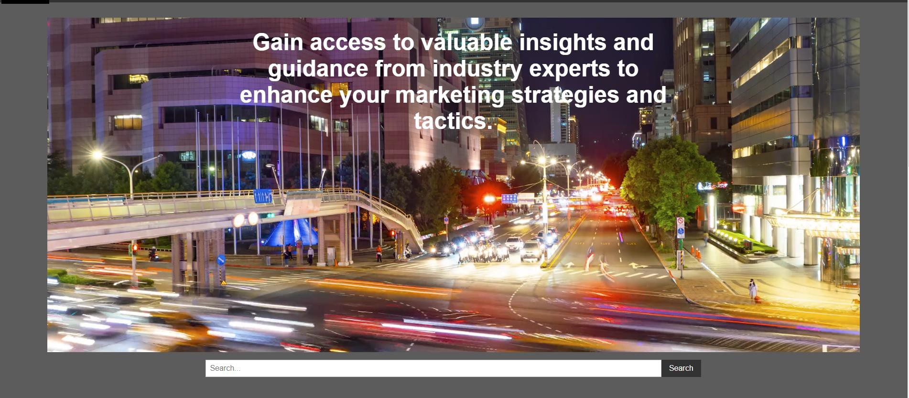

# MAIN BANNER WITH VIDEO

1. The highlight of the main banner is a dynamic video that plays in a full-width format of 100% by 700px.
2. This engaging element helps to capture visitors' attention right from the start.
3. The banner also includes a prominent search bar to facilitate quick access to content.

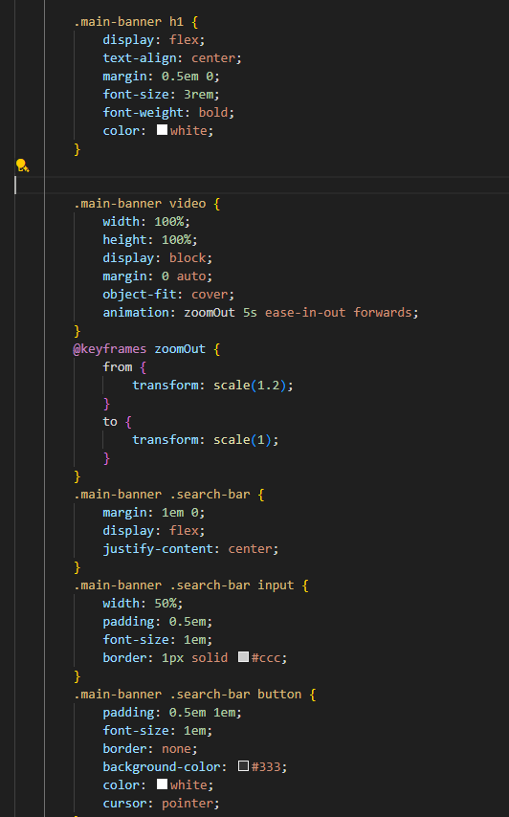

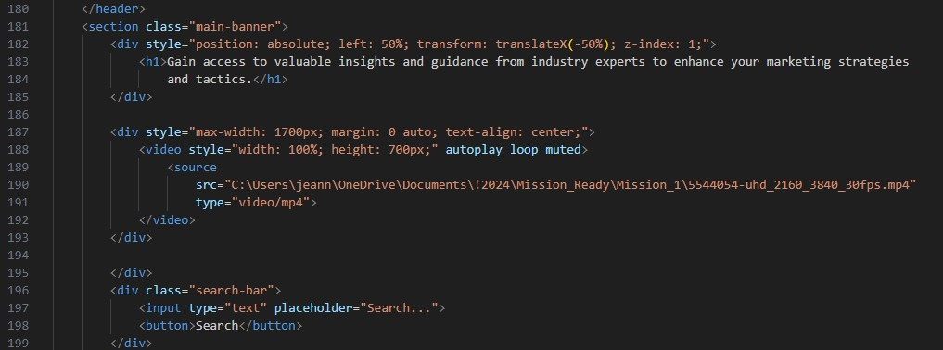

12

13



The content section features cards that display key information with accompanying images.

This section is designed to be visually appealing and easy to digest, with each card providing an animation of the content.

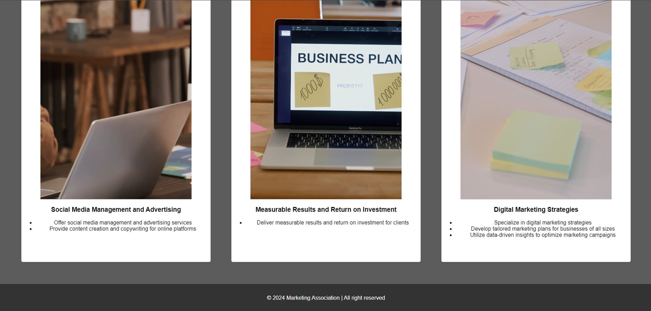CONTENT SECTION

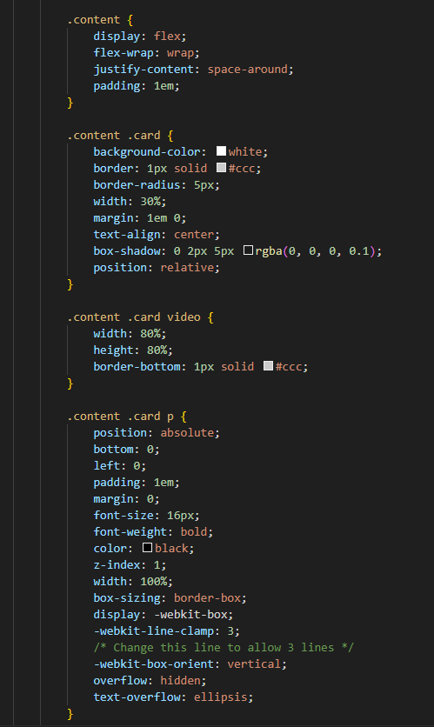

14

15



# FOOTER

The footer provides essential company information and quick links, ensuring that visitors can easily access important details and navigate the site efficiently.

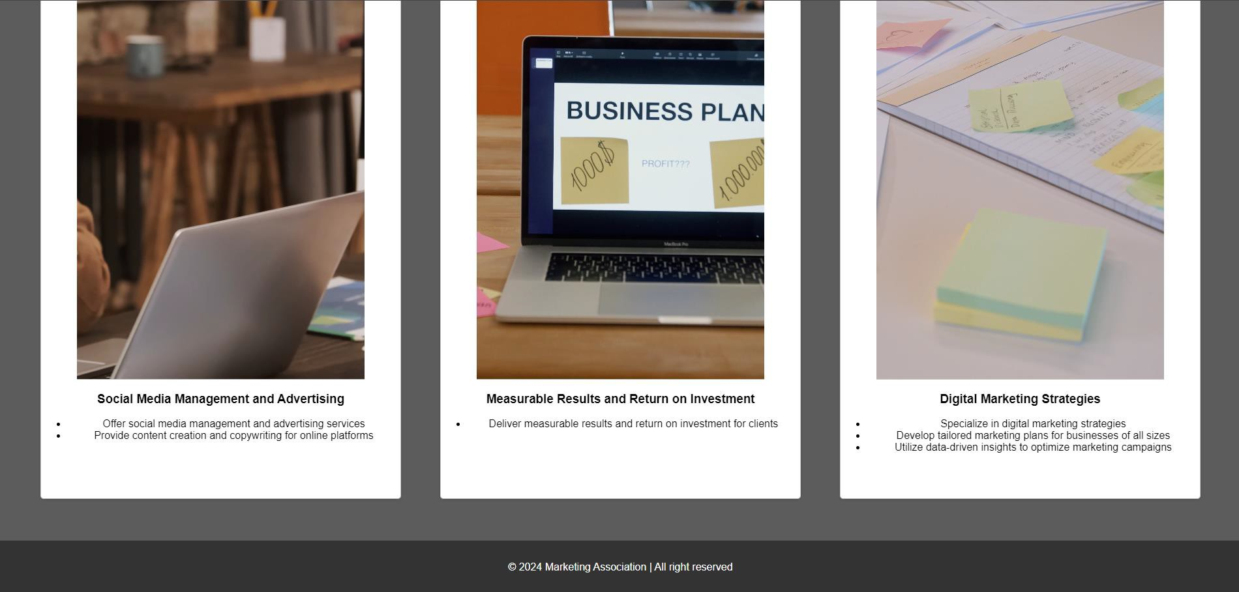

16

17

# TECHNICAL FEATURES

**HTML and CSS:** The foundation of this website, ensuring a structured and visually appealing layout.

**Responsive Design:** Media queries ensure that the website adapts seamlessly to different screen sizes.

**CSS Animations:** The video element includes a zoom- out effect, autoplay loop, enhancing visual engagement.



THANK YOU

FOR YOUR ATTENTION.

I AM NOW OPEN TO ANY QUESTIONS YOU MAY HAVE.

Jeanny Gere van Erkel